CREATE TABLE DEPARTMENT1(DEPARTMENT_ID NUMBER PRIMARY KEY,DEPARTMENT_NAME VARCHAR(20));

INSERT INTO DEPARTMENT1 VALUES(1001,'MARKETING');

INSERT INTO DEPARTMENT1 VALUES(1002,'FINANCE');

INSERT INTO DEPARTMENT1 VALUES(1003,'HR');

INSERT INTO DEPARTMENT1 VALUES(1004,'IT');

SELECT*FROM DEPARTMENT1;

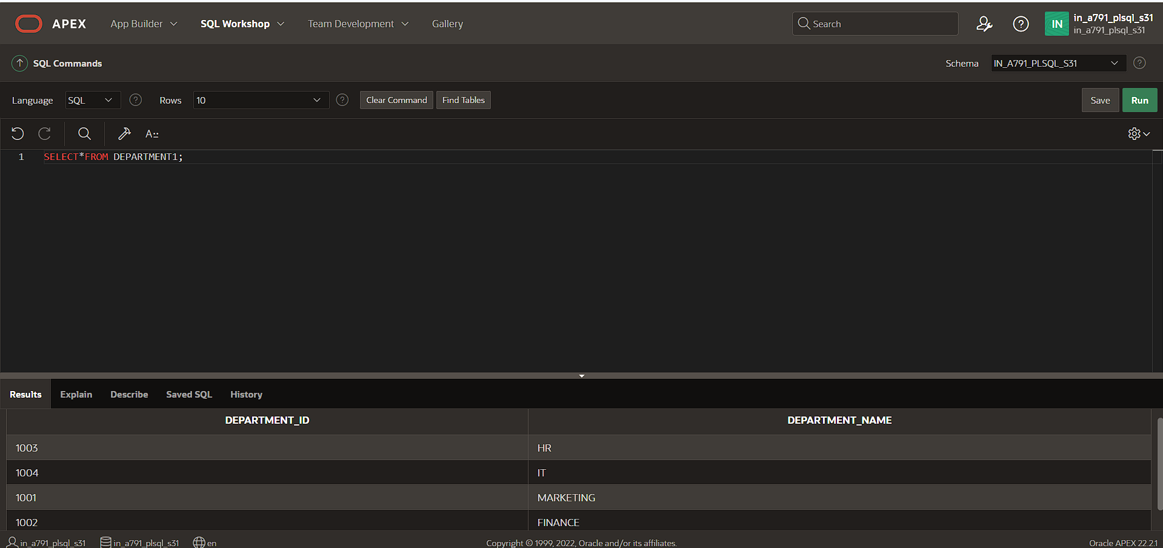

CREATE TABLE EMPLOYEE1(EMPLOYEE_ID NUMBER PRIMARY KEY,EMPLOYEE_NAME VARCHAR(20),DEPARTMENT_ID NUMBER,FOREIGN KEY (DEPARTMENT_ID)REFERENCES DEPARTMENT1(DEPARTMENT_ID));

INSERT INTO EMPLOYEE1 VALUES(2018,'VIRAT',1001);

INSERT INTO EMPLOYEE1 VALUES(2017,'ROHIT',1002);

INSERT INTO EMPLOYEE1 VALUES(2016,'PANT',1003);

INSERT INTO EMPLOYEE1 VALUES(2015,'HARDIK',1004);

SELECT*FROM EMPLOYEE1;

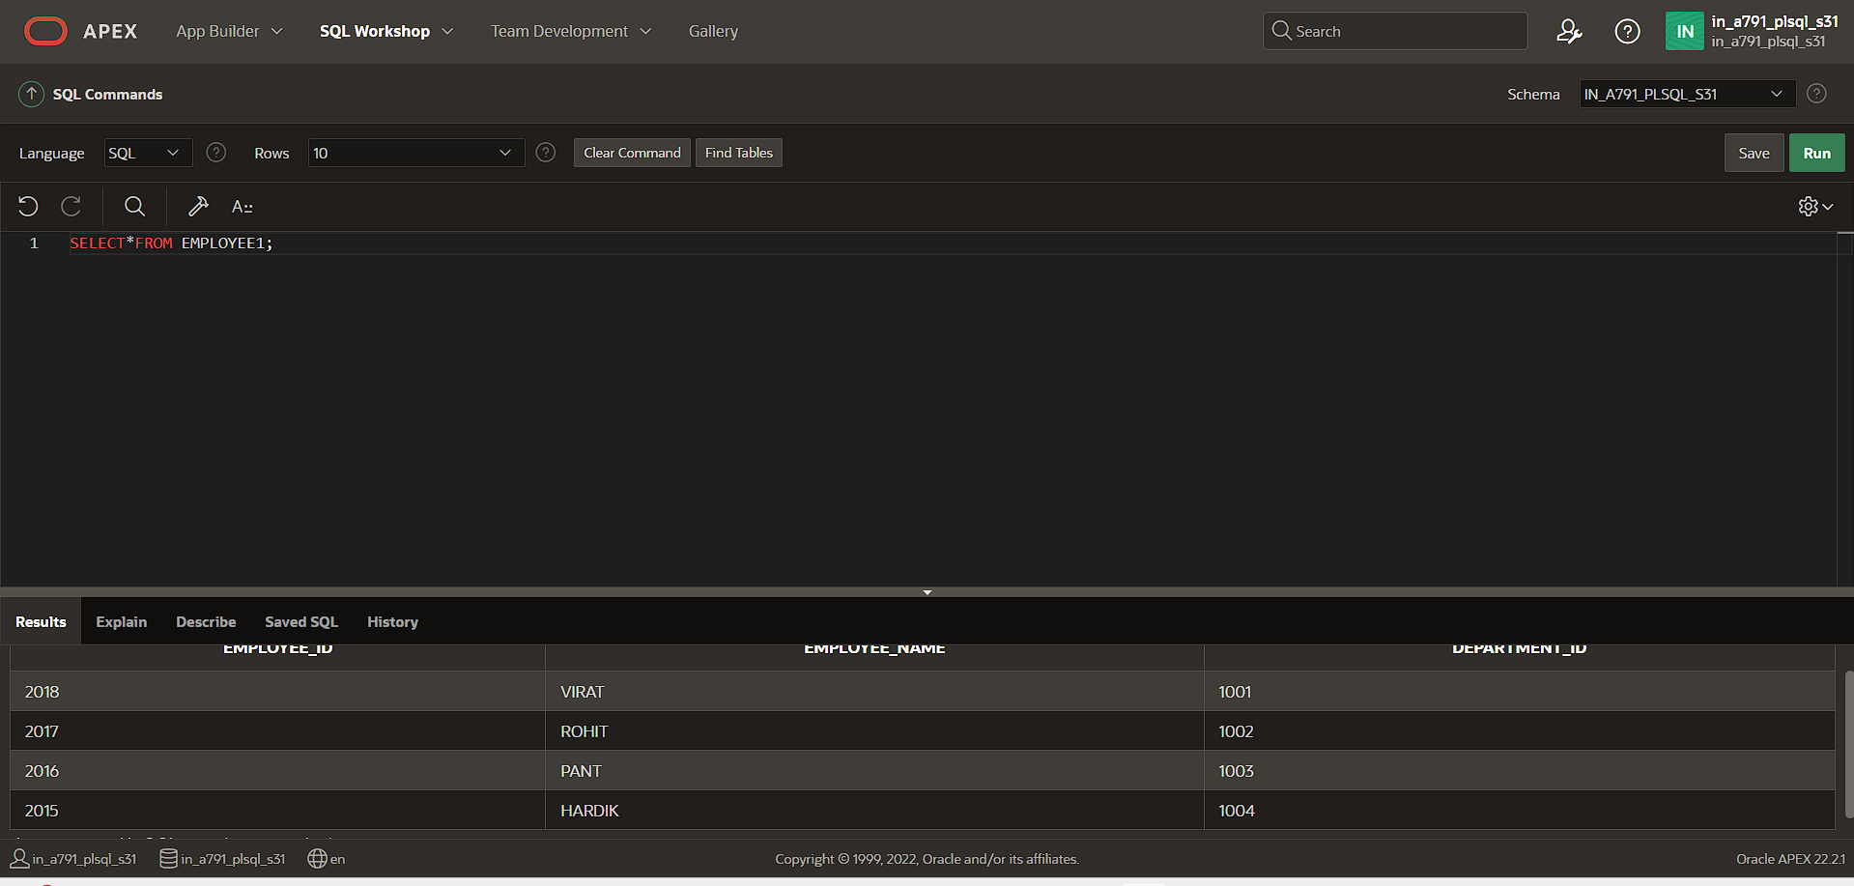

SELECT EMPLOYEE1.EMPLOYEE_NAME,DEPARTMENT1.DEPARTMENT_NAME FROM EMPLOYEE1 LEFT JOIN DEPARTMENT1 ON EMPLOYEE1.DEPARTMENT_ID = DEPARTMENT1.DEPARTMENT_ID;

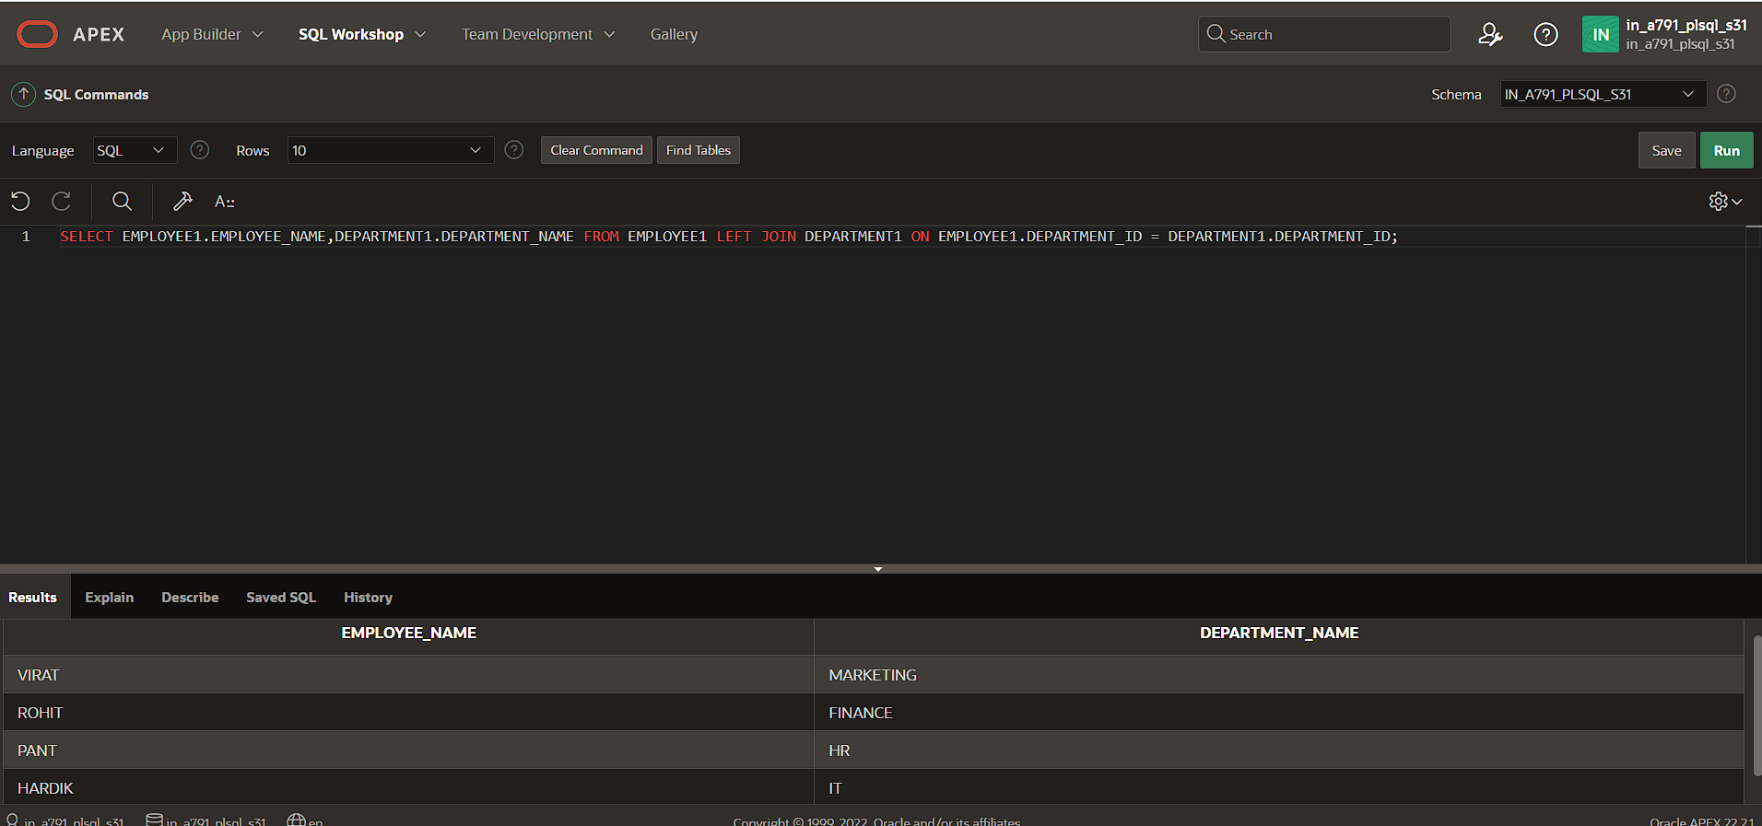

SELECT DEPARTMENT1.DEPARTMENT_NAME,EMPLOYEE1.EMPLOYEE_NAME FROM DEPARTMENT1 RIGHT JOIN EMPLOYEE1 ON EMPLOYEE1.DEPARTMENT_ID = DEPARTMENT1.DEPARTMENT_ID;

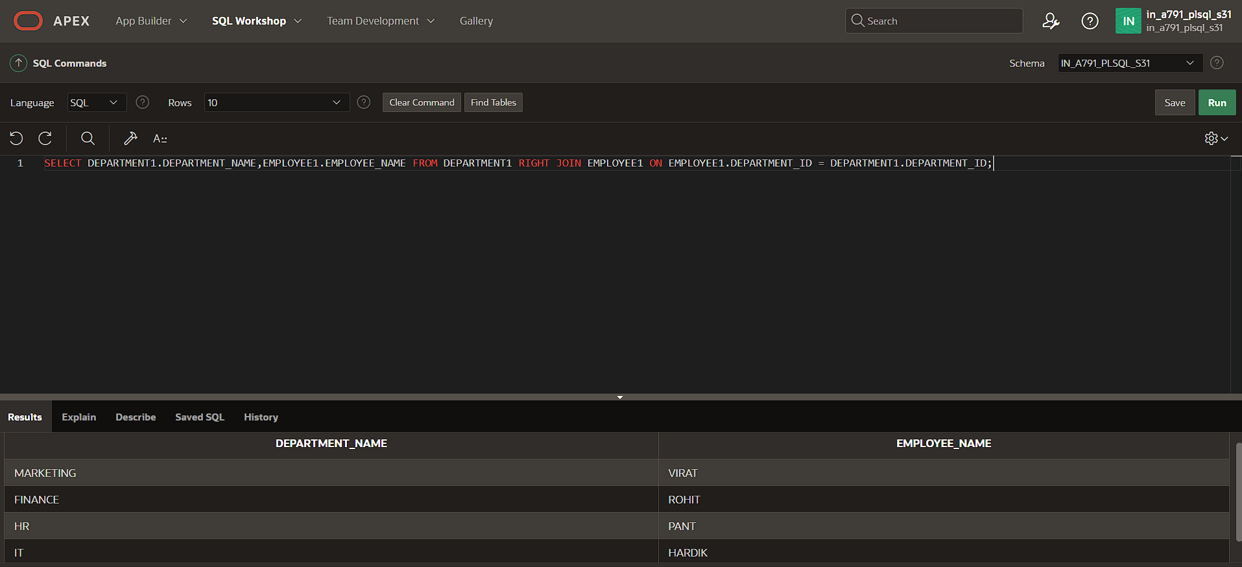

SELECT EMPLOYEE_ID,DEPARTMENT_ID,DEPARTMENT_NAME FROM EMPLOYEE1 NATURAL JOIN DEPARTMENT1 ;

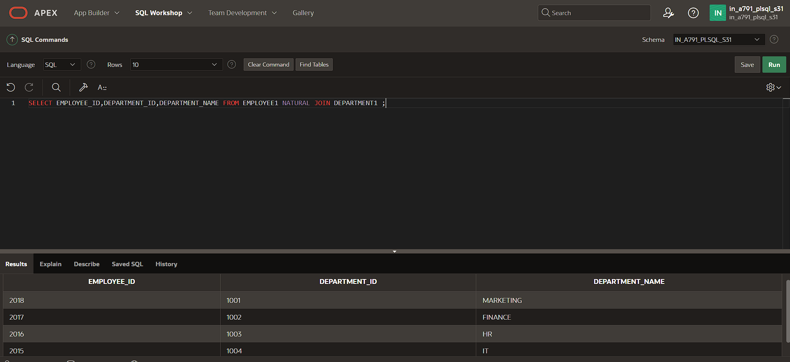

SELECT a.EMPLOYEE_ID,b.DEPARTMENT_NAME FROM EMPLOYEE1 a JOIN DEPARTMENT1 b ON a.DEPARTMENT_ID=b.DEPARTMENT_ID;

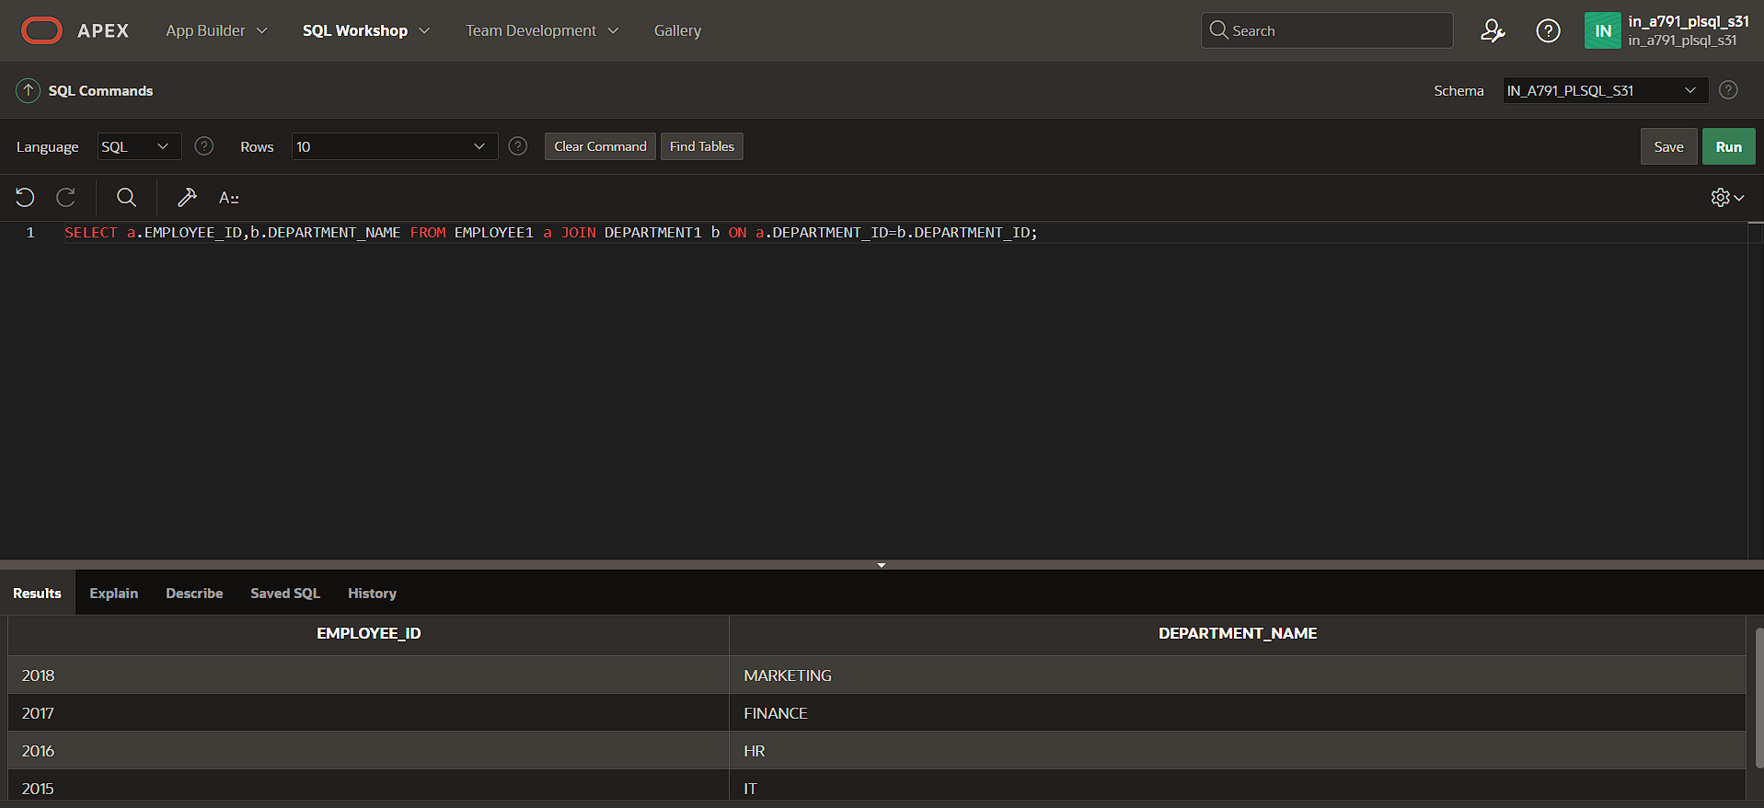

select EMPLOYEE_ID,EMPLOYEE_NAME, DEPARTMENT1.DEPARTMENT_ID,DEPARTMENT_NAME from EMPLOYEE1 FULL OUTER JOIN DEPARTMENT1 on EMPLOYEE1.DEPARTMENT_ID =DEPARTMENT1.DEPARTMENT_ID;

